Linux Commands: Modifying a text file in Directory
1). Creating a Directory:
Syntax: mkdir directory_name
Command: mkdir test_dir
SS:
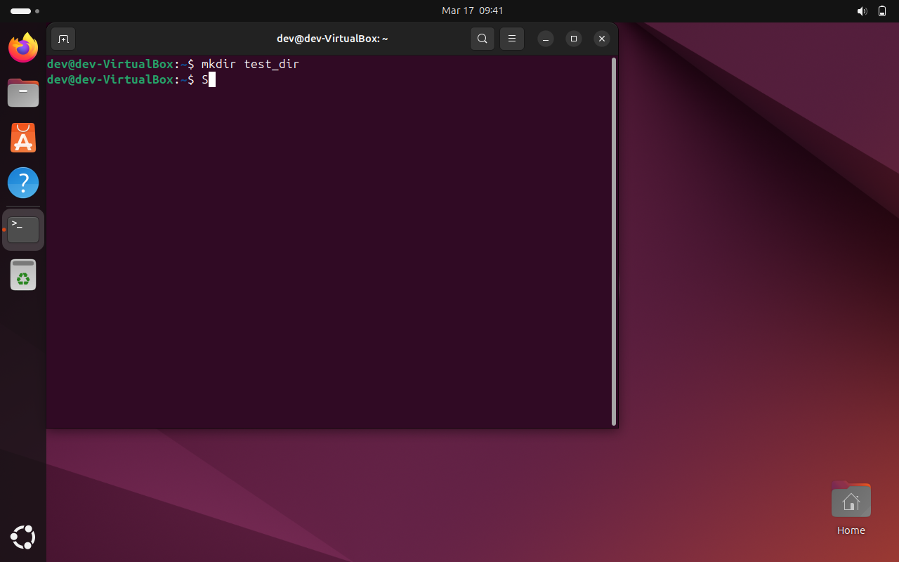

2). Creating a file in test_dir:
Syntax1: cd directory_name
Command1: cd test_dir
Syntax2: touch file_name.extention
Command2: touch example.txt
SS:
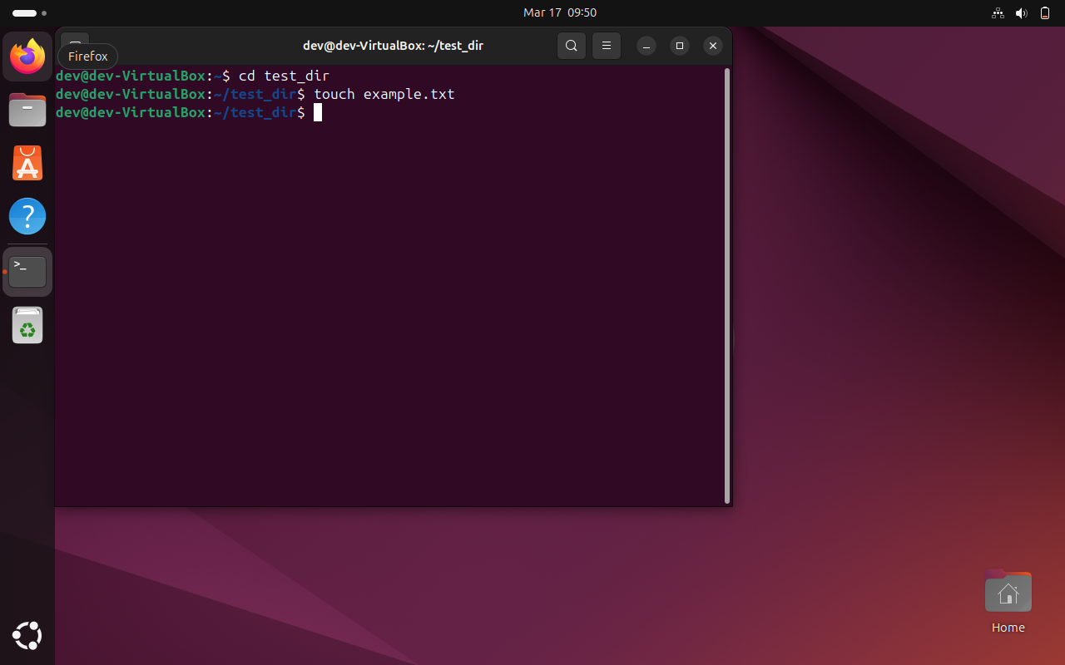

3). Renaming a File:
Syntax: mv old_file_name new_file_name
Command: cd test_dir
SS:
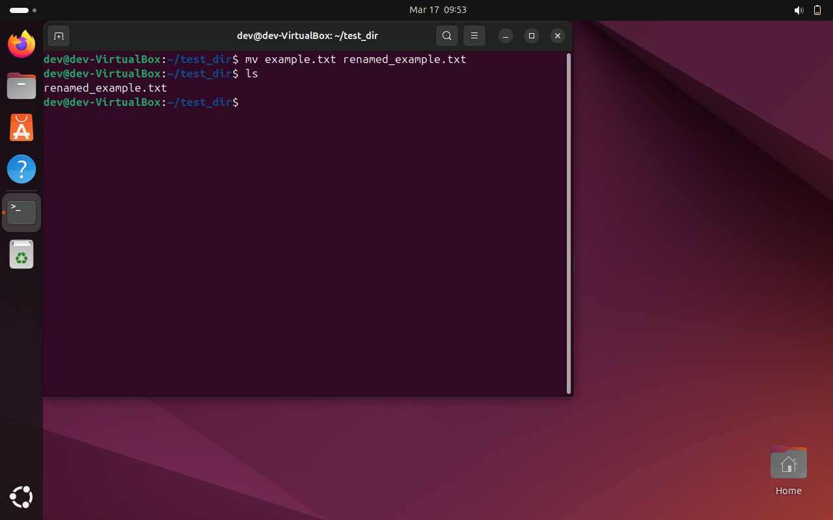

Linux Commands: Viewing File Contents
1). Use cat to display the contents of /etc/passwd:
Command1: cd ~
Syntax2: cat path_of_file or file_name
Command2: cd /etc/passwd
SS:
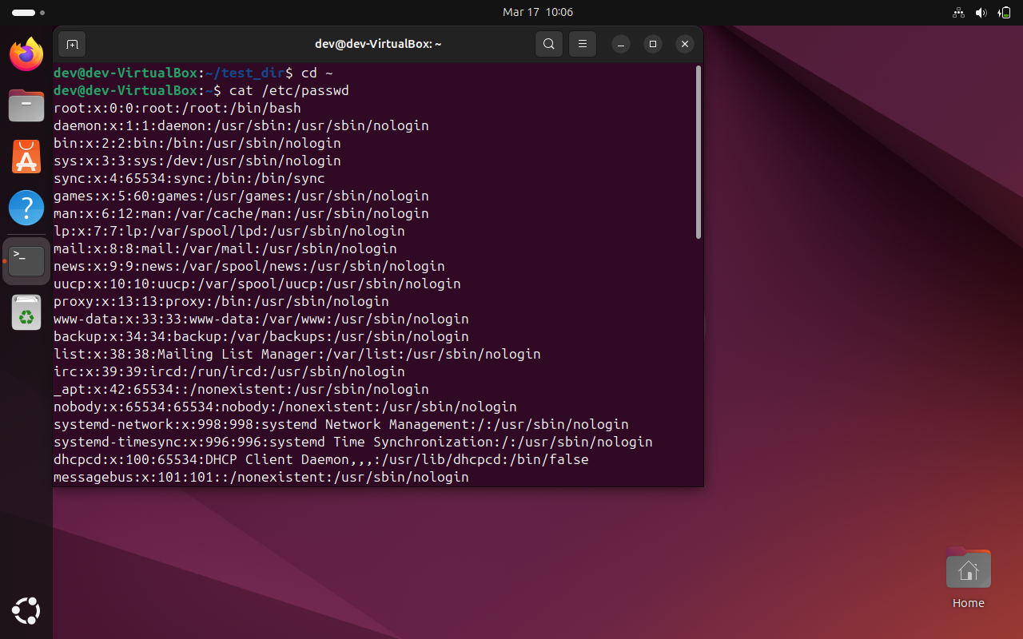

2). Display only the first 5 lines of /etc/passwd using head:
Syntax: head file_name or file_path
Command: head /etc/passwd
SS:
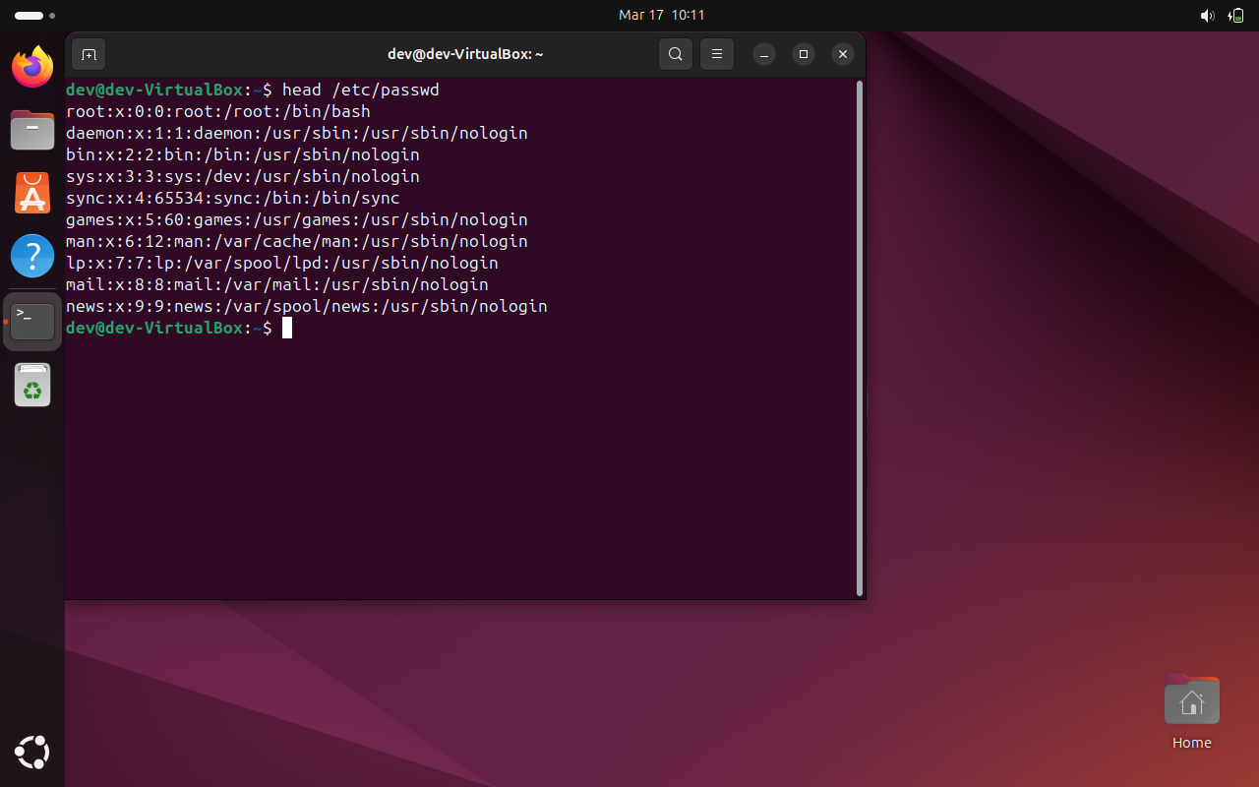

3). Display only the last 5 lines of /etc/passwd using tail:
Syntax: tail file_name or file_path
Command: tail /etc/passwd
SS:
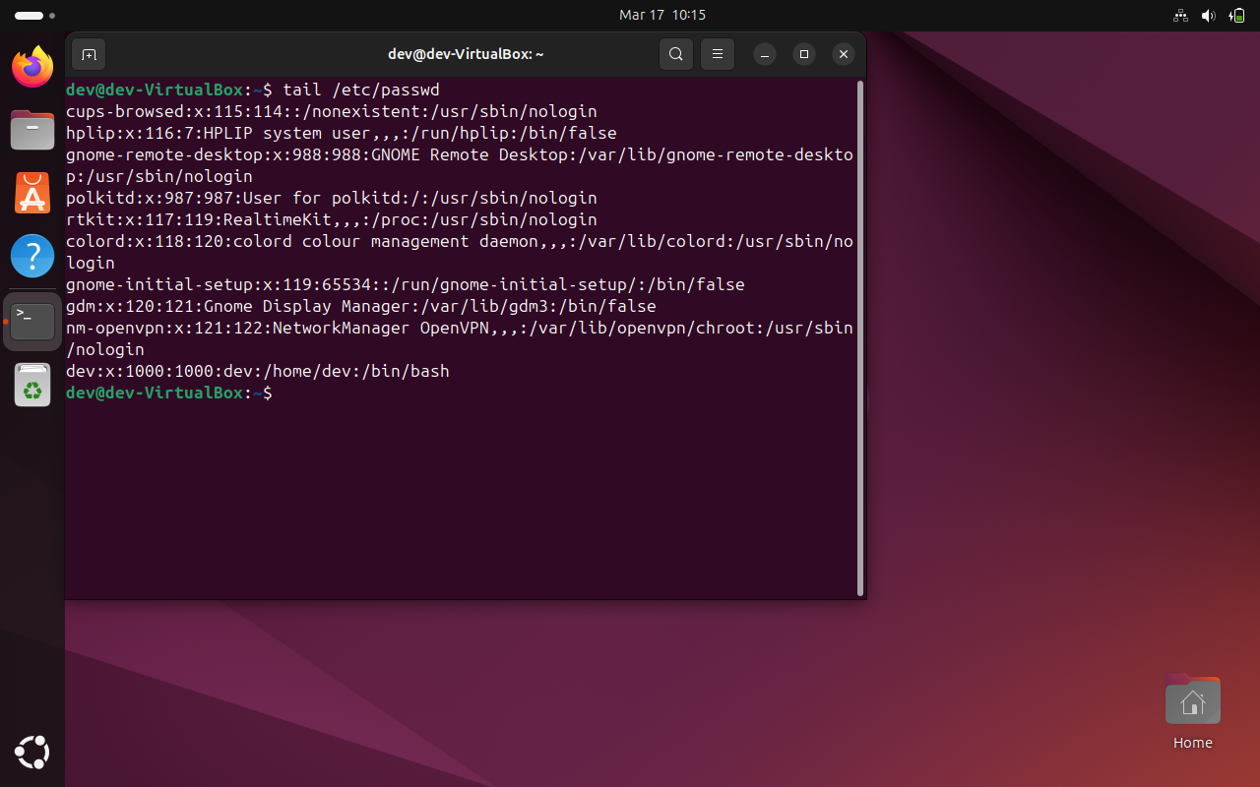

Linux Commands: Searching for Patterns
1). Use grep to find all lines containing the word "root" in /etc/passwd:
Syntax: cat path_of_file or file_name | grep “word_you_want”
Command: cd /etc/passwd | grep “root”
SS:
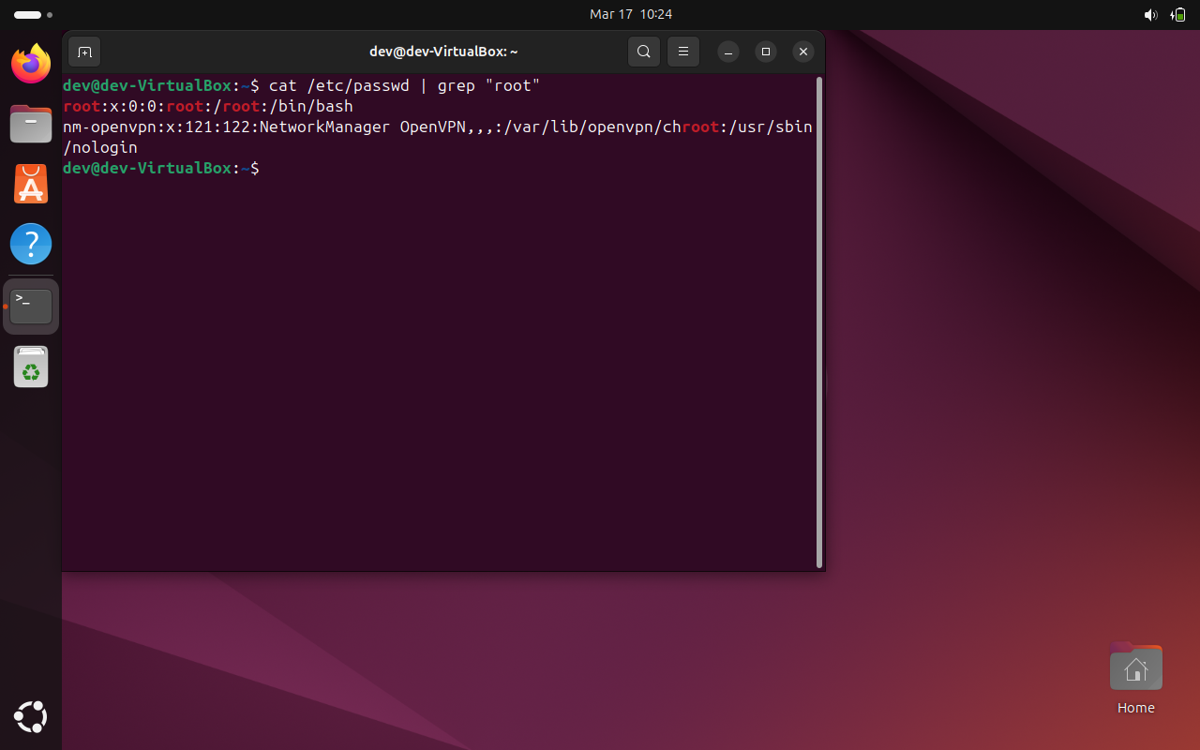

Linux Commands: Zipping and Unzipping
1). Compress the test_dir directory into a file named test_dir.zip using zip:
Syntax: tar -cvf archieve_file_name.zip directory_name
Command: tar -cvf test_dir.zip test_dir
SS:
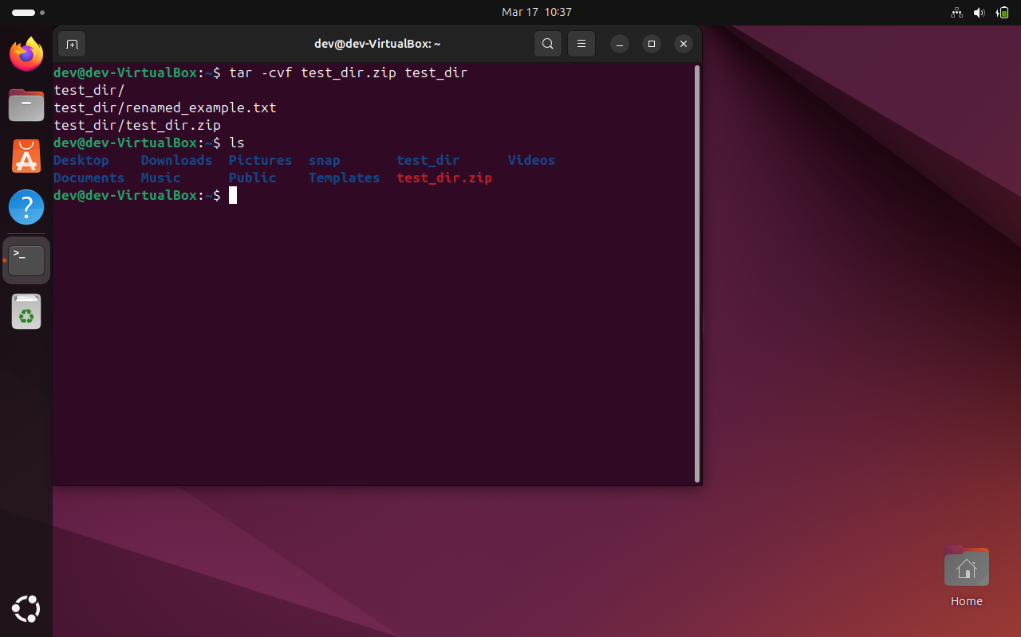

2). Unzip test_dir.zip into a new directory named unzipped_dir:
Syntax: tar -xvf archieve_file_name.zip directory_name
Command: tar -xvf test_dir.zip test_dir
SS:
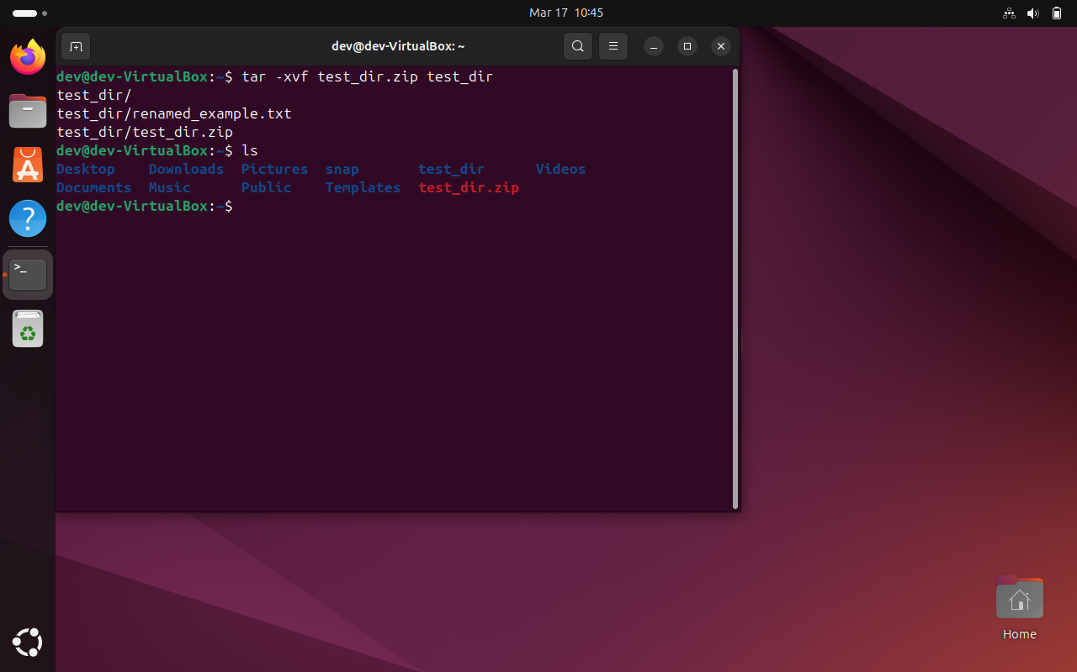

Linux Commands: Downloading Files
1). Use wget to download a file from a URL (e.g., https://getsamplefiles.com/download/txt/sample-1.txt):
Syntax: wget -d <url>
Command: wget -d https://getsamplefiles.com/download/txt/sample-1.txt
SS:
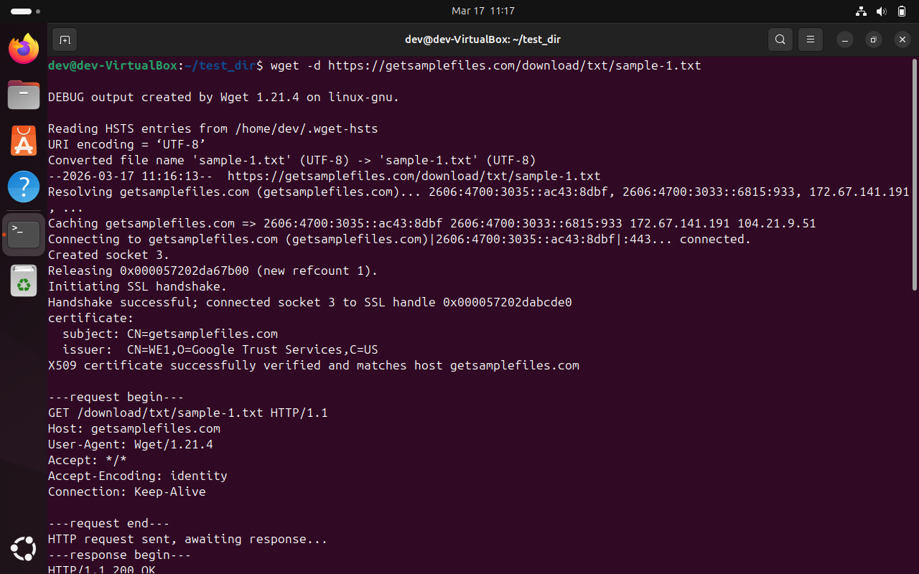
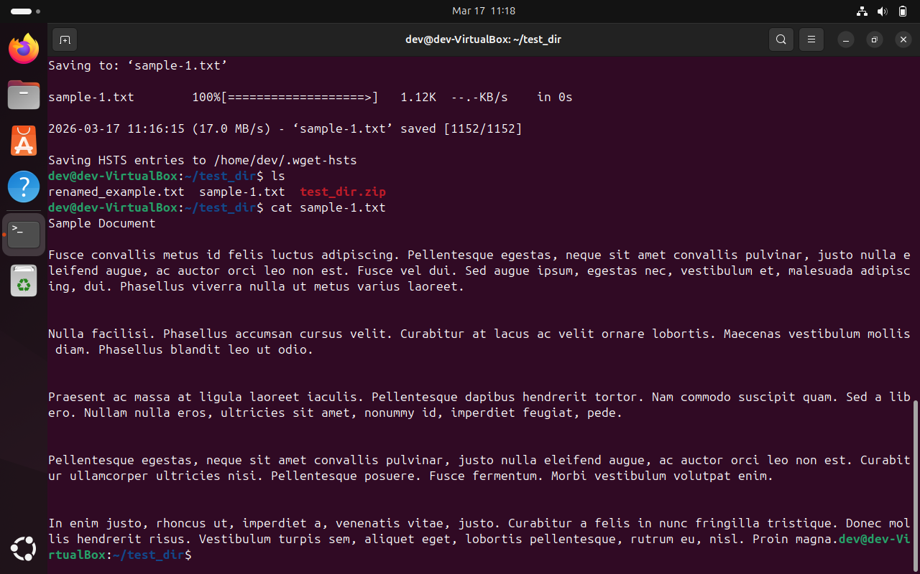

Linux Commands: Changing Permissions
1). Create a file named secure.txt and change its permissions to read-only for everyone using chmod:
Syntax2: chmod permission file_name.txt
Command2: chmod 444 secure.txt
SS:
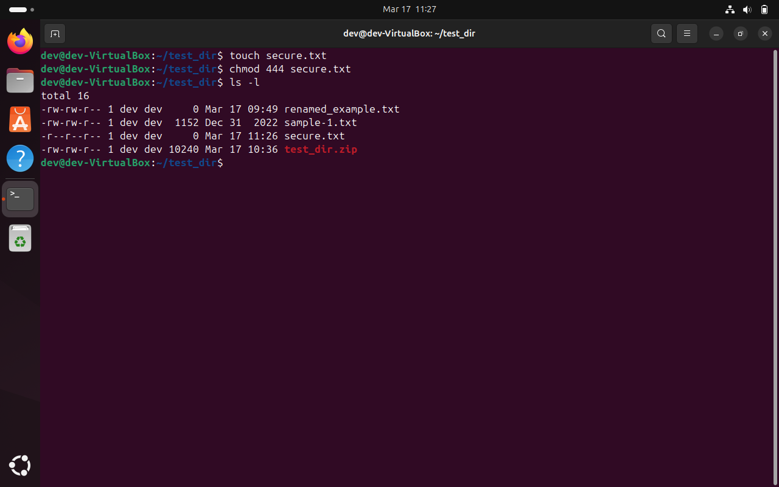

Linux Commands: Working with Environment Variables
1). Use export to set a new environment variable called MY_VAR with the value "Hello, Linux!":
Syntax1: export variable_name=“variable”
Command1: export MY_VAR=“Hello, Linux!”
Syntax2: echo $variable_name
Command2: echo $MY_VAR
SS:
